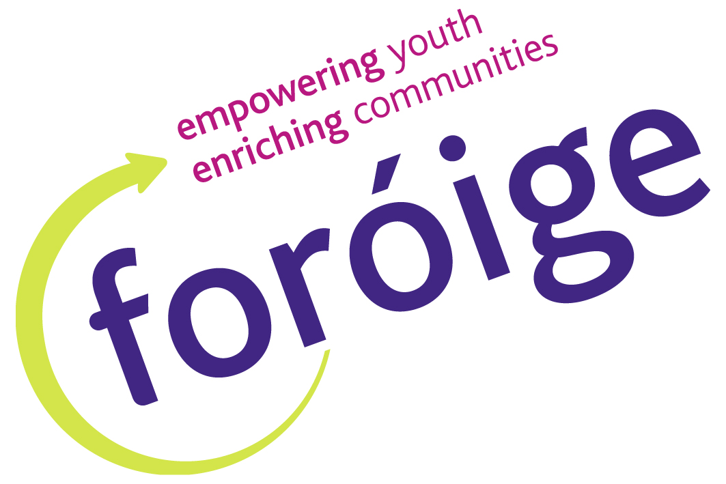
Albert Schweitzer’s Leadership for Life Application Form
Personal Details:

Name: ____________________________ Sex: Male Female

Address: ____________________________ Date of Birth: ____ / _____ /_____

____________________________ Tel: ___________________ (home)

____________________________ ___________________ (mobile)

Email: ____________________________

I would like to take part in the NUI Galway accredited Foundation Certificate in Youth
Leadership and Community Action Yes □ No □

Leadership Qualities:

Please outline why you are interested in doing the youth leadership programme?

_____________________________________________________________________________________________________________________

_____________________________________________________________________________________________________________________

_____________________________________________________________________________________________________________________

_____________________________________________________________________________________________________________________

_____________________________________________________________________________________________________________________

What leadership skills do you feel you have?

_____________________________________________________________________________________________________________________

_____________________________________________________________________________________________________________________

_____________________________________________________________________________________________________________________

_____________________________________________________________________________________________________________________

_____________________________________________________________________________________________________________________

_____________________________________________________________________________________________________________________

What leadership skills would you like to gain?

_____________________________________________________________________________________________________________________

_____________________________________________________________________________________________________________________

_____________________________________________________________________________________________________________________

_____________________________________________________________________________________________________________________

Please give an example of how you have demonstrated leadership.

____________________________________________________________________________________________________________________________________________________________

_____________________________________________________________________________________________________________________

_____________________________________________________________________________________________________________________

_____________________________________________________________________________________________________________________

____________________________________________________________________________________________________________________________________________________________

_____________________________________________________________________________________________________________________

During the leadership programme you will be expected to develop a leadership goal. Please give details of a goal you would like to achieve and the steps you would take to do so.

_____________________________________________________________________________________________

_____________________________________________________________________________________________

_____________________________________________________________________________________________

_____________________________________________________________________________________________

_____________________________________________________________________________________________

_____________________________________________________________________________________________

_____________________________________________________________________________________________

_____________________________________________________________________________________________

How committed are you to completing this programme? (circle one)
Very Committed Committed Slightly committed Not at all committed

During the programme you will be expected to spend time outside of the sessions completing a workbook. Do you agree to this? Yes □ No □

Places are limited. Application deadline is Wednesday 19th of September 2012.

Signed __________________________________ Date: ______________________________
(Participant)

Please send completed applications to:
Sue Redmond, 7 Gort an tSamhraidh, Claregalway, Co. Galway

